EXPERIMENT:08

NAME:KRISHNAKUMAR.R ROLL NO: 240701275

Experiment: User Flow in a Mobile Shopping App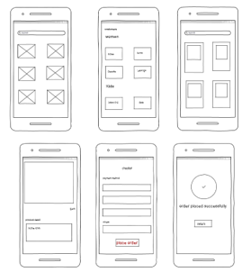

Aim
To study and validate the step-by-step process of online shopping through a mobile application interface, from browsing products to order confirmation.
Apparatus
- Smartphone with prototype shopping app (wireframe screens)
- Internet connection (assumed)
- User account
Procedure
- Step 1 – Product Grid (Observation Stage)
  - User opens the app and sees a grid of product/category placeholders.
  - Hypothesis: The grid layout helps quick visual browsing.
- Step 2 – Category List (Controlled Variable)
  - User navigates to categories: sportswear, t-shirt, jeans, sweater, shoes, hat.
  - Independent variable: Category chosen.
  - Dependent variable: Products displayed.
- Step 3 – Product Options (Testing Samples)
  - User views four product placeholders within the chosen category.
  - Action: Selects one product for deeper analysis.
- Step 4 – Product Detail (Analysis Stage)
  - Product page shows image, description, and “Buy” button.
  - Observation: User can evaluate product features before purchase.
- Step 5 – Checkout Form (Data Collection)
  - User enters payment method, name, address, phone number.
  - Action: Clicks “Place Order.”
  - Hypothesis: Correct data entry ensures successful transaction.
- Step 6 – Order Confirmation (Result Stage)
  - Screen shows checkmark and “Order placed successfully.”
  - Outcome: Hypothesis confirmed — the app supports a complete purchase cycle.
Observations
- Each screen logically follows the previous one.
- The flow minimizes confusion by guiding the user step by step.
- Essential details (product info, payment, confirmation) are captured at the right stage.
Conclusion
The experiment validates that the wireframe design supports a smooth shopping journey. The user can browse, select, purchase, and confirm an order in six clear steps, demonstrating effective interface design.

